# **1. INTRODUCTION**

Banks play an important role in every country’s economic development. In day-to-day life, everybody needs banks. But most of the people, especially the first-timers, struggle to know various procedures and processes required to get their work done at the bank and avail of its different products and services. Currently banks have their own web-sites, mobile applications and facilities like internet banking, mobile banking but sometimes, these sources can be a bit overwhelming for most of the users who are either not well versed with technology or in some cases where the information is too scattered to search foreasily. There are different types of platforms provided by different banks but people are facing problems accessing them (different GUIs, too much navigation). Although Customer Care centres are available, there are lot of wait times and redirection in some cases, leaving the customer with no choice but to experience considerable delays getting a simple informational query resolved. People have queries about various bank policies, loans, fixed deposits. This results in unnecessary crowd in banks for inquiry. Banks also face problems solving repeated queries of customers. This is time consuming and banking staff gets frustrated. Manpower and money gets wasted for separate inquiry counter. A chat bot is a conversational agent that interacts with users in a certain domain on certain topic with natural language sentences. Normally a chat bot works by a user asking a question or initiating a new topic. Chat bots can be called as software agents that simulate an entity usually a human. These are the software with artificial intelligence which allows them to understand users input and provide meaningful response using predefined knowledge.

This banking bot project is built using artificial algorithms that analyses user’s queries and understand user’s message. We are going to design system for banks where users can ask any bank related questions like loan, account, policy etc. This application will be developed for web users. The system will recognizes user’s query and understands what he wants to convey and simultaneously answers them appropriately. Even if the user does not frame sentence properly system will understands the query and answer accordingly. There is no specific format the user must follow to ask questions. The built in artificial intelligence system realizes users requirements and provides suitable answers to the user.

Banking has become the part and parcel of everyone’s life. Almost everyone uses the banking sector to perform their tasks. Most of the tasks are been carried out manually. Now the use of mobile and internet banking facility has reached greater heights. Chat bots is becoming trending today. They are computer programs that interact with users using natural languages. In this project we are trying to perform few of the basic banking operations via chat bots. Now bots in banking sectors are only used to give guidelines but in this bot, we perform banking operations for a list of few banks.

Developing a chat bot will provide a smart solution to solvethese queries, provide information as and when required,improve service and increase number of customers. It removeshuman factors included in organization and can give 24/7 hoursservice to increase productivity. We intend to provide a chat botinterface for customers which could be available on the web andon any hand-held devices. Customers can mention their queries in natural language and the chat bot can respond to them withcorrect answer. Proposed chat bot application is easily accessibleto customer thereby solving redundant queries anywhereanytime. As there will be fast response for inquiry, this will betime saving for both bank and customers. The proposed systemwould be a stepping stone in having in place an intelligent queryhandling program which could in next phases not just respondbut self-learn to improve itself thereby increasing not just thequality of customer service but also reducing human load,increase in productivity and of course increasing number ofsatisfied customers.

Current chat bots are developed using variety of methods likerule based where rules are hard-coded in code, AI based bots,pattern-based which can handle only mentioned patterns forretrieving answer. There are frameworks available fordeveloping chat bots but they also use either rule-based orpattern-based techniques. In rule based chat bots which areeasiest to build, one need to write rules like If X then Y else if Athen B etc. So if there are 100 scenarios, developer needs to write100 rules for each of the scenarios. The volume, variety andcomplexity of data makes such techniques inefficient. Its nearly impossible to write rules and/or patterns for massively availabledata. AI based bots are built on NLP and ML. They are based onhuman capability of learning information but with moreefficiency. Natural Language Processing (NLP) can be used wherepredefined or static rules, patterns may not work.

Augmented Reality or **A.R** is a way by which technology can change how we perceive the world around us. It’s also very useful in various fields, but first we need to know what is augmented reality and how it is different from virtual reality.

A.R. is made up of the word “augment” which means to make something great by adding something to it. So basically, augmented reality is a method by which we can alter our real world by adding some digital elements to it. This is done by superimposing a digital image on the person’s current view thus it enhances the experience of reality.

##### **2. LITERATURE REVIEW**

In day-to-day life, everybody needs banks. As we know nowadays its tedious to go in particular banks and sometimes the banks may be too far from the customer’s residence. In day-to-day life, everybody needs banks. Mostly the new customers may feel struggle while knowing the procedures and details and avail of its different products and services. Currently banks have their own web-sites, mobile applications and facilities like internet banking, mobile banking but sometimes, these sources can be a bit overwhelming for most of the users who are either not well versed with technology or in some cases where the information is too scattered to search for easily. We are developing a virtual assistant who will resolve the queries of user. Although Customer Care centers are available, there are lot of wait times and redirection in some cases, leaving the customer with no choice but to experience considerable delays getting a simple information.[4]

People have queries about various bank policies, loans, fixed deposits. We intend to provide a chat bot interface for customers which could be available on the web and on any hand-held devices. A chat bot is a conversational agent that interacts with users in a certain domain on certain topic with natural language sentences. This system will provide a smart solution to solve these queries, provide information as and when required improve service and increase number of customers., The assistant will understand the users queries and give appropriate results. In this system the assistant will be a voice based and will give voice based answers. The user will be provided with all the necessary information about the banks. It will provide information to the user at any time. The bot will be user friendly and make the user feel easier to use and get their work done. The responses for users will be given fast thereby saving users time. We will create datasets for information about the particular banks.[4]

The proposed system would be a stepping stone in having in place an intelligent query handling program which could in next phases not just respond but self-learn to improve itself thereby increasing not just the quality of customer service but also reducing human load, increase in productivity and of course increasing number of satisfied customers.The use of chatbots has continued until the present day in the form of apps that provide an illusion of conversation with a human as well as in areas such as education, information retrieval, business, and e-commerce, for example, as automated online assistants to complement or even replace human- provided services in a call center.[2]

**3. METHODLOGY**

**3.1 Problem Definition**

Banks generally are crowded and it is needed in our day-to-day life. Customers need to go to bank and wait to the enquiry counter and ask their queries which is time consuming and tedious task. The customers have various queries regarding the banks policies, fixed deposits, interest rates, loan related information and most important the documents that will be needed by the customer. The customer just need to take these documents and get his work done. In banks, at customer care centres and enquiry desks, human is insufficient and usually takes long time to process the single request which results in wastage of time and also reduce quality of customer service. The customers which are not known with the banks information and is a new user will get the information instantly and will not have to wait unnecessarily in the banks.

The proposed system will be easier for the customer to use and get the information. The user needs to register himself by giving username, password and email-id to be authenticated user. The user after logging in can ask the bot his query and the bot will understand the query and give the information accordingly. This is a smart system which provides results instantly. This system will be helpful in reducing workload of employees. The customer will also get the information about the nearest branch of the bank and also the nearest ATM. This will help him to go to his nearest branch which will be convenient for him. It will be a customer’s personal banking assistant. The customers will ask the bot in the natural language and get the information based on the pre-knowledge provided to the chat bot. This will also increase the customer satisfaction.

**3.2 Proposed Experiment Work**

Most chatbots try to mimic human interactions, which can frustrate users when a misunderstanding arises. Watson Assistant is more. It knows when to search for an answer from a knowledge base, when to ask for clarity and when to direct users to a human. Watson Assistant can be deployed in any cloud or on-premises environment – meaning smarter AI is finally available wherever you need it. IBM Watson Assistant is a white label cloud service that allows enterprise-level software developers to embed an artificial intelligence (AI) virtual assistant (VA) in the software they are developing and brand the assistant as their own. The service, which gives consumers access to Watson AI , is delivered through the IBM Cloud.

Watson Assistant, which uses Watson AI machine learning (ML) and natural language understanding (NLU), is marketed to businesses that want to have the option of keeping the data that flows through their virtual assistant private. Unlike other vendors that aggregate the information their virtual assistants gather, IBM offers developers the choice of isolating the information their assistant gathers in a private cloud to protect proprietary insights gained through user interaction. Users can interact with the developer’s application through a variety of interfaces, including voice and touch.

IBM has released a virtual assistant developer toolkit to make it easier for enterprises to integrate intelligent bots with business and collaboration applications. The vendor’s application sends user input to the Watson Assistant service, which can interact with the vendor’s back-end systems. Watson can create cognitive profiles for each end user’s behaviors and preferences and initiate conversations to make recommendations. IBM also provides developers with a catalog of already configured customer service and industry content packs for automotive and hospitality verticalindustries. Developers can also modify Watson Assistant's responses to create an artificial personality that reflects the brand's demographics.

When you activate one of the assistants, your request is immediately packaged up and sent to the servers owned by the company of your respective device. This is why, if you have a poor network connection, your virtual assistant might be slow. Upon arrival, the words and tone of your request are analyzed by an algorithm, which are then matched with a command that it thinks you asked. Essentially it’s saying “we’re eighty-five percent sure you asked this question,” which is why you don’t always get the answer you were looking for. If the algorithm isn’t certain enough, it may ask “did you mean blank?” and give you its best guess as to what you wanted. Or it could say “I’m sorry I can’t do that yet.”

While the algorithm is analyzing the question, your phone or smart speaker is trying to figure out if it can handle the command without needing information from the sever. For example, a request like “Can you pause the music?” is simple; if you want the assistant to translate a phrase from Italian to English, that’s more complicated. Assuming your request is more complicated than a local command, your device will communicate back to the server and continue cross-checking your question to make sure it knows what you’re asking.

Finally, your request is answered. If you asked your assistant for the answer to a trivial question, it will find that answer from the web (Google, Bing, etc.) and push the response back to your device. If you asked your Echo to turn on your smart lights, a signal will be sent to them via Wi-Fi, and they will turn on. The complexity is in relation to the speed of task fulfillment and understanding what you want on the first try. Once the assistant knows what it needs to do, that’s a basic process of tapping into a server, third-party computer, or other electronic device. Some virtual assistants specialize in a specific skill set. For example, a marketing or PR virtual assistant only does marketing or PR work. Other virtual assistants do a variety of duties but within a specific industry. For example, a real estate virtual assistant does many tasks, but only for Realtor clients.

**Conversational AI** in particular, has seen a lot of interest in recent years, with a number of banks implementing AI-powered conversational solutions. Bots, be it **chatbots** or **voice bots**, can conduct smart and compelling conversations on behalf of the bank with millions of consumers, at a **fraction of the cost of using human customer service staff**. The interactive nature of Conversational AI, and its speed and efficiency go a long way towards enhancing the customer experience. To effectively leverage Conversational AI, banks needed to restructure some minor portions of their business processes. Still, given the long-term benefits, banks have been rather quick at biting the bullet.

With chatbots gaining more traction, many firms across the globe have started offering off-the-shelf products that help developers to build, test, host and deploy these programs using Artificial Intelligence Markup Language (AIML), an open source specification for creating chatbots3. A few platforms support integration with payment providers for seamless processing of customer payments based on a customer’s interaction with the bot.

For Augmented reality you only need a modern smart phone then you can easily download an AR app like Google’s “**just a line**” and try this technology. There’s also a different way to experience augmented reality, though special AR headsets, such as “**Google Glass**“, where digital content is displayed on a tiny screen in front of a user’s eye or “**Microsoft Hololens**” which displays the information in real-world all you have to do is wear the headset and you can see the digital images.

**3.3 System Architecture**

Chatbot is an intelligent piece of software that is capable of communicating and performing similar actions similar to a human. Chatbots are used a lot in customer interaction, marketing on social network sites and instantly messaging the client.

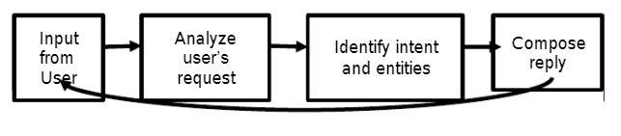

**Figure 3.1: Architecture of Chatbot**

The chatbot architecture follows two different models. These are on the basis of as to how they operate. These models are Rule based and Artificial intelligence-based models. A rule based chatbot uses predefined input patterns and responses. It then uses some type of heuristic approach to select the appropriate response. It is widely used in the industry to make goal- oriented chatbots where we can customize the tone and flow of the chatbot to drive our customers with the best experience. Artificial intelligence models are not based on some predefined responses.[4]

User will interact with the system using web application. He will enter his query in text box provided on front end of this web application. Once he presses Enter button or submit the query, this request will be handled by bot controller logic.

The bot controller logic contains implementation of Flask framework for handling user requests and sending answer to those queries as response. Then, the query will be sent to Business logic and Machine learning logic. Business logic contains pre-processing of user input query using Natural Language Processing (NLTK library) and its vectorization. NLP will tokenize the query, remove unnecessary spaces, stop-words and then extract lemmas for each token. Then this text-format query will be converted to vectorized format using vectorization. Now, using ML logic, classification algorithm will be applied to this transformed query to find the class it belongs to. Classification algorithm will be applied based on the previous saved model executed on train data. All questions from input data having class equal to retrieved class will be fetched and cosine similarity will be applied to these. According to similarity values we get, most similar answer will be returned to user as response.

**3.4 Feedback System**

In this mechanism, an agent is responsible for taking the user’s feedback from time to time to verify that either the bot is working correctly with the dialogues of the user or the user is satisfied with the Responses of the bot. This thing supports the chatbot to understand all the mistakes and to improve itself for future conversation.

There are situations where chat bot cannot give right answer or cannot have answer to asked question because the question is out of database. For such circumstances, we have developed feedback mechanism for our chat bot. Web application will have Dislike button along with submit button. Then log file will be generated for this query or the query will be inserted into already created log file. Developer comes into picture now for handling such situations. He will check classes for these queries, enter right answers and will retrain the classification model. So that whenever user enters the same query next time he will get correct answer. In this way chat bot improves its accuracy. The entered queries will be sent in the form of email to the developer and the developer will assess the query and work on it accordingly to give the response to the user. We proposed this system to take users feedback so that we can get information about the users needs and will make the future changes in the project.

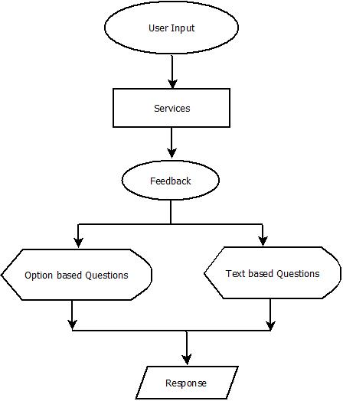

**Figure 3.2: Flow chart for Feedback System.**

It is a GUI based feedback system (chatbot) which takes feedback from the user and feedback gets updated in database and the administrator will receive email regarding feedback.

There are situations where chat bot cannot give right answer or cannot have answer to asked question because the question is out of database. For such circumstances, we have developed feedback mechanism for our chat bot. Web application will have Dislike button along with submit button. If in case user is not satisfied with the answer provided by system, he can press this Dislike button. Then log file will be generated for this query or the query will be inserted into already created log file. Developer comes into picture now for handling such situations. He will check classes for these queries, enter rightanswers and will retrain the classification model. So that whenever user enters the same query next time he will get correct answer. In this way chat bot will improve its accuracy and dataset.

**3.5 Data Flow Diagram**

**DFD** is the abbreviation for **Data Flow Diagram**. The flow of data of a system or a process is represented by DFD. It also gives insight into the inputs and outputs of each entity and the process itself. DFD does not have control flow and no loops or decision rules are present. Specific operations depending on the type of data can be explained by a flowchart. Data Flow Diagram can be represented in several ways. The DFD belongs to structured-analysis modeling tools. Data Flow diagrams are very popular because they help us to visualize the major steps and data involved in software-system processes.

User

Dashboard

**Figure 3.3: DFD Level 0**

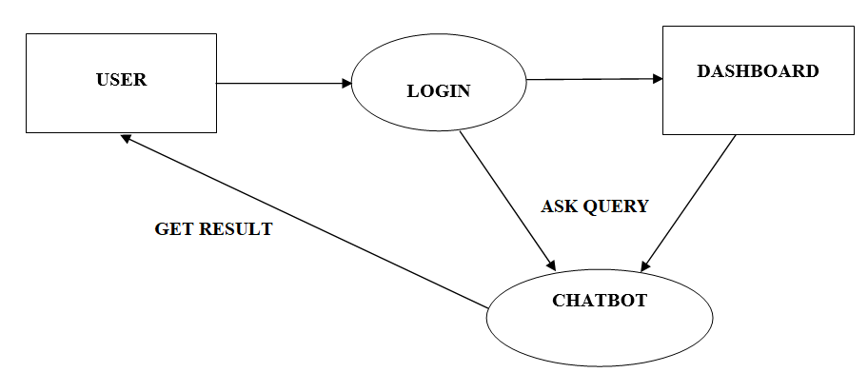

**Figure 3.4: DFD Level 1**

**3.5 Activity diagram**

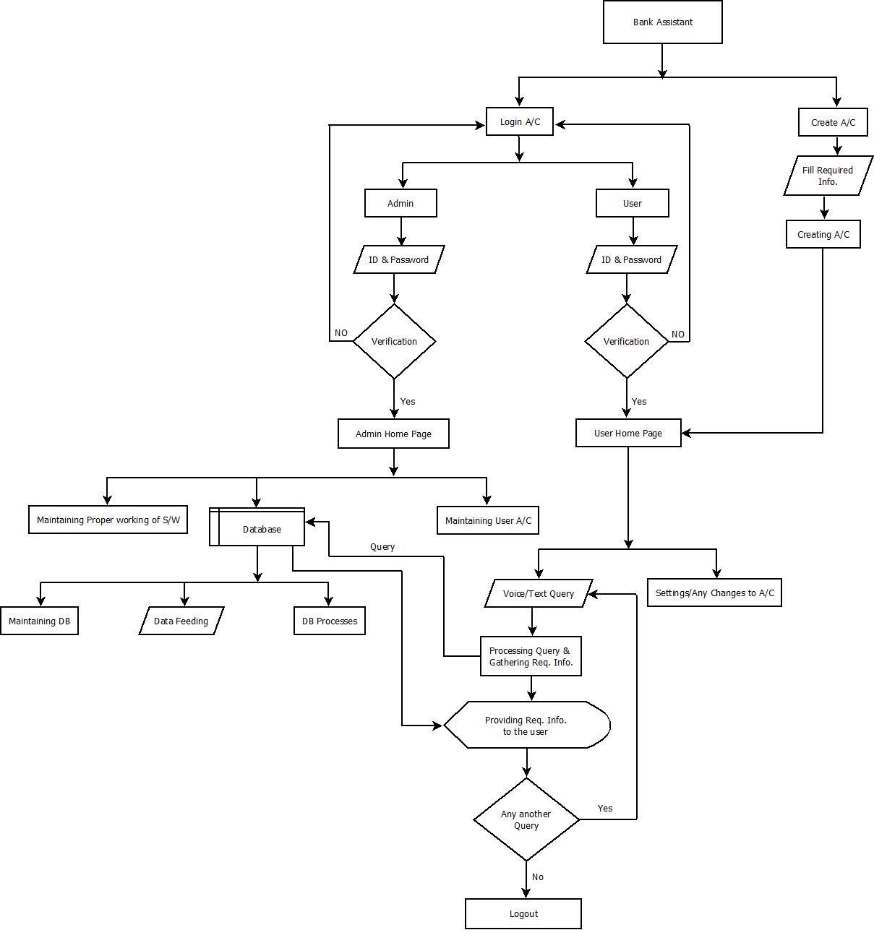

**Figure 3.5: Activity diagram**

**4. MODULES DEVELOPED**

1. Web Pages

A web page is often used to provide information to viewers, including pictures or videos to help illustrate important topics. A web page may also be used as a method to sell products or services to viewers.

a)

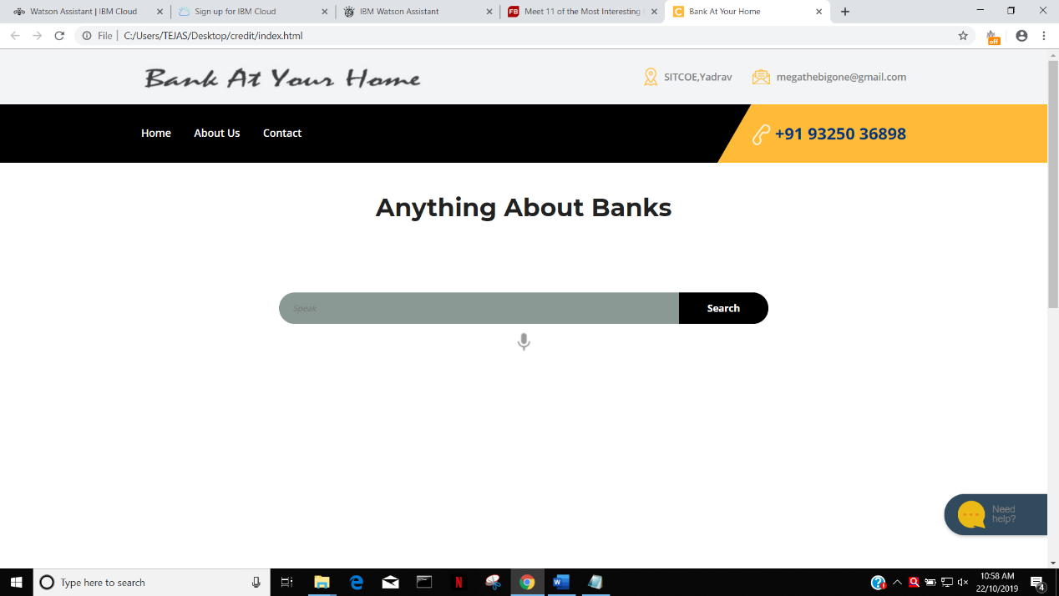

**Figure 4.1 Home Page**

When user opens the website welcome page will be displayed which contains search bar on which user will type the information and a mic icon where he clicks on it and he needs to ask the query.

b)

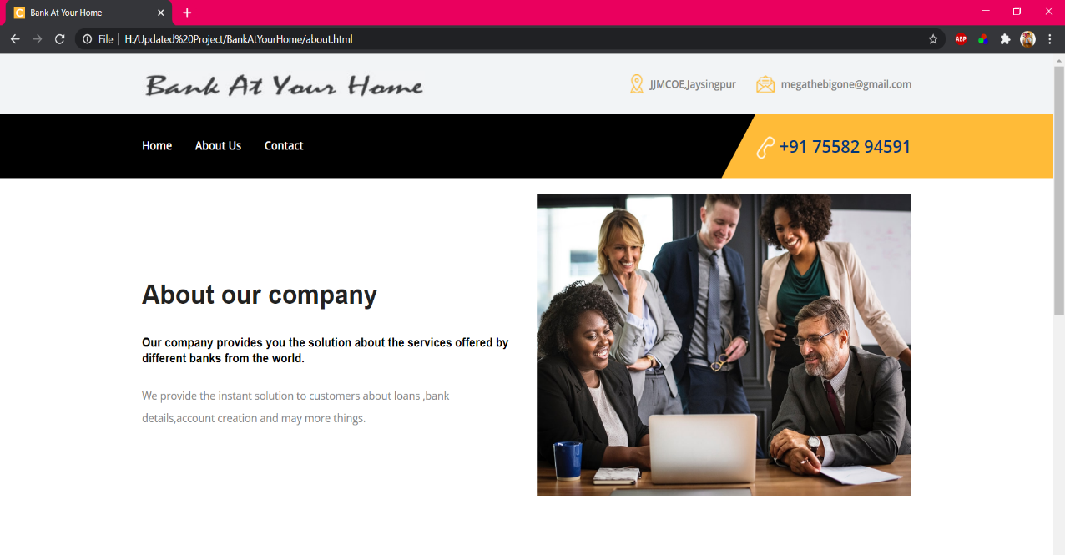

**Figure 4.2 About Us Page**

We provide you the solution about the services offered by different banks

c)

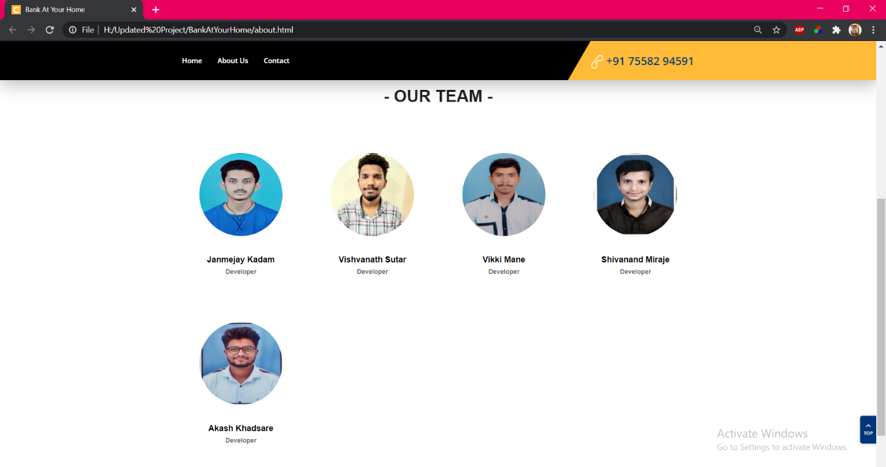

**Figure 4.3 Our Team**

2 Chatbot

It is also known as “conversational agents” which are software applications that mimic written or spoken human speech for the purposes of simulating a conversation or interaction with a real person. There are two primary ways chatbots are offered to visitors: via web-based applications.

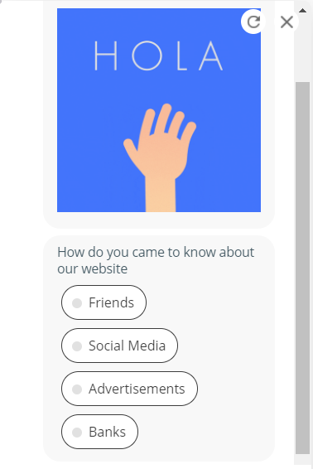 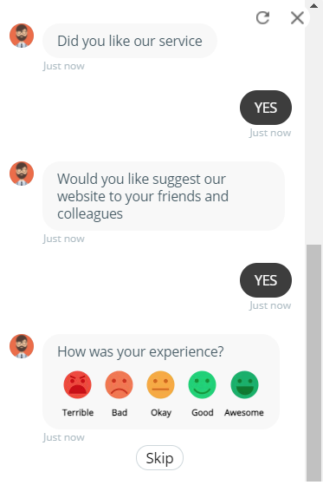

**Figure 4.4 Chatbot**

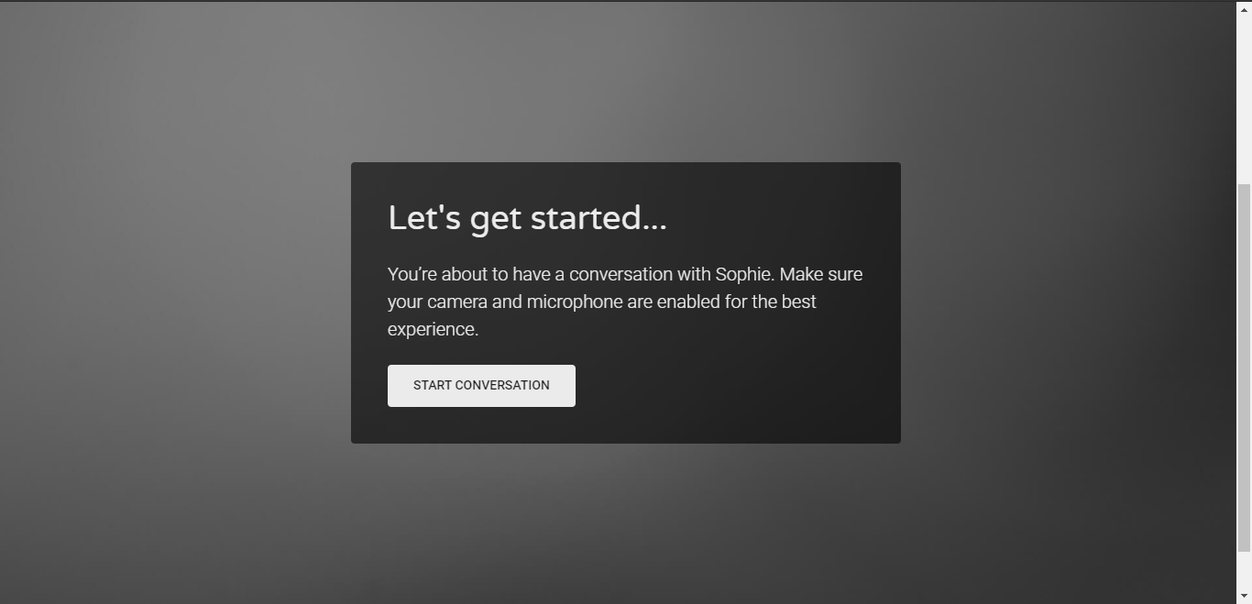

**Figure 4.5 Let’s go**

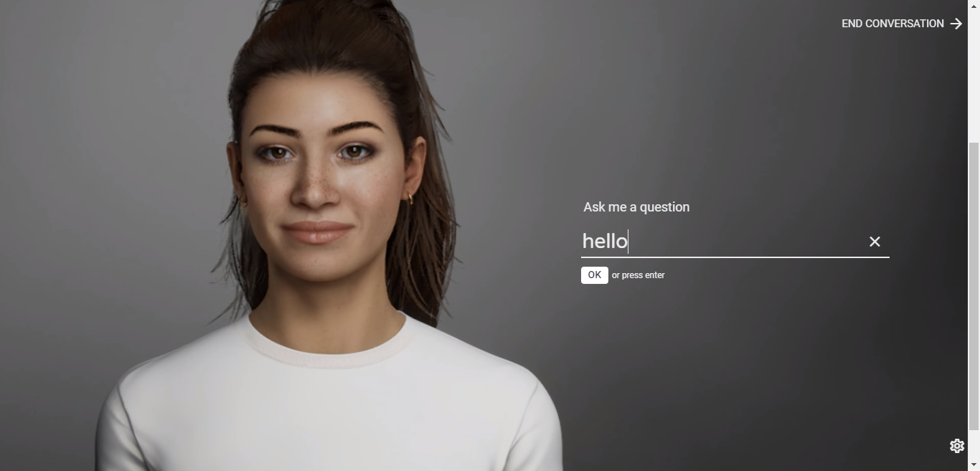

**Figure 4.6 Hello_Sophie**

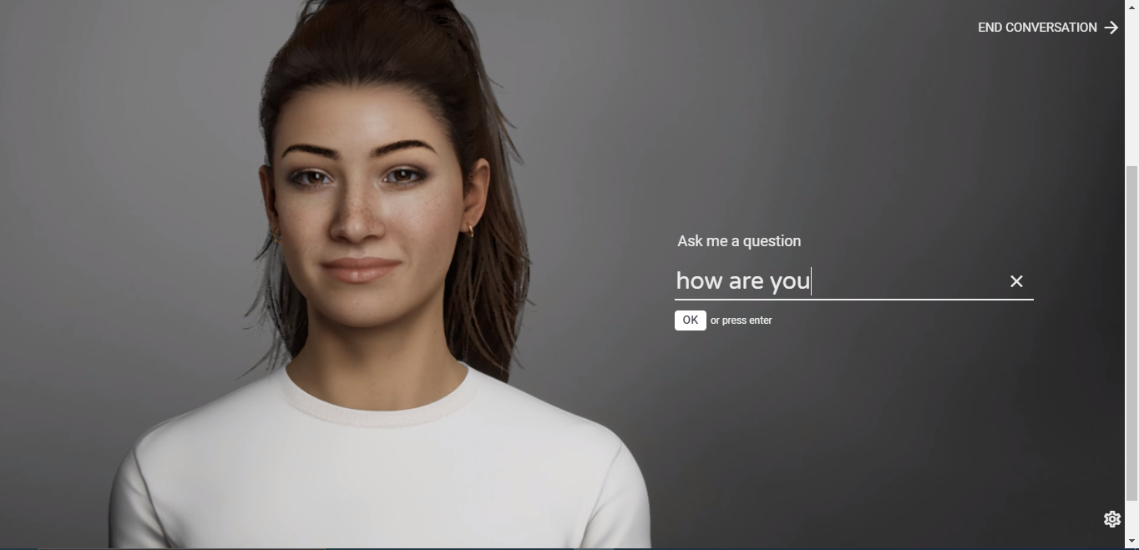

**Figure 4.7 Asking ‘How are you?’**

**5. IMPLEMENTATION TOOLS**

The implementation tools used for this system are as,

HTML,

Python 3.7,

SQL database, &

Notepad ++

a. HTML

HTML stands for Hypertext Markup Language, and it is the most widely used language to write Web Pages. Hypertext refers to the way in which Web pages (HTML documents) are linked together. Thus, the link available on a webpage is called Hypertext.As its name suggests, HTML is a Markup Language which means you use HTML to simply "mark-up" a text document with tags that tell a Web browser how to structure it to display. Originally, HTML was developed with the intent of defining the structure of documents like headings, paragraphs, lists, and so forth to facilitate the sharing of scientific information between researchers. Now, HTML is being widely used to format web pages with the help of different tags available in HTML language.

HTML elements are the building blocks of HTML pages. With HTML constructs, images and other objects such as interactive forms may be embedded into the rendered page. HTML provides a means to create structured documents by denoting structural semantics for text such as headings, paragraphs, lists, links, quotes and other items. HTML elements are delineated by *tags*, written using angle brackets. Tags such as <img/> and <input/> directly introduce content into the page. Other tags such as <p> surround and provide information about document text and may include other tags as sub-elements. Browsers do not display the HTML tags, but use them to interpret the content of the page.

HTML can embed programs written in a scripting language such as JavaScript, which affects the behavior and content of web pages. Inclusion of CSS defines the look and layout of content. The World Wide Web Consortium (W3C), former maintainer of the HTML and current maintainer of the CSS standards, has encouraged the use of CSS over explicit presentational HTML since 1997.

b. Python 3.7

**Python** is an open source programming language that was made to be easy-to-read and powerful. A Dutch programmer named Guido van Rossum made Python in 1991. He named it after the television show Monty Python's Flying Circus. Many Python examples and tutorials include jokes from the show.

Python is an interpreted language. Interpreted languages do not need to be compiled to run. A program called an ((interpreter runs Python code on almost any kind of computer. This means that a programmer can change the code and quickly see the results. This also means Python is slower than a compiled language like ((C, because it is not running machine code directly.

Python is a good programming language for beginners. It is a high-level language, which means a programmer can focus on what to do instead of how to do it. Writing programs in Python takes less time than in some other languages.

Python drew inspiration from other programming languages like C, C++, ((Java, Perl, and Lisp.

Python's developers try to avoid changing the language to make it better until they have a lot of things to change. Also, they try not to make small repairs, called patches, to unimportant parts of the CPython reference implementation that would make it faster. When speed is important, a Python programmer can move some of the work of the program to other parts written in programming languages like C or PyPy, a just-in-time compiler. It translates a Python script into C and makes direct C-level API calls into the Python interpreter.

Python is used by hundreds of thousands of programmers and is used in many places. Sometimes only Python code is used for a program, but most of the time it is used to do simple jobs while another programming language is used to do more complicated tasks.

Its (standard library is made up of many functions that come with Python when it is installed. On the Internet there are many other (((libraries available that make it possible for the Python language to do more things. These libraries make it a powerful language; it can do many different things.

Some things that Python is often used for are:

Web development

Scientific programming

Data science

Machine learning

Numerical analysis

Statistics

c. SQL

**Structured Query Language** is a domain-specific language used in programming and designed for managing data held in a relational database management system (RDBMS), or for stream processing in a relational data stream management system (RDSMS). It is particularly useful in handling structured data, i.e. data incorporating relations among entities and variables.

SQL offers two main advantages over older read–write APIs such as ISAM or VSAM. Firstly, it introduced the concept of accessing many records with one single command. Secondly, it eliminates the need to specify *how* to reach a record, e.g. with or without an index.

Originally based upon relational algebra and tuple relational calculus, SQL consists of many types of statements, which may be informally classed as sublanguages, commonly: a data query language (DQL), a data definition language (DDL), a data control language (DCL), and a data manipulation language (DML). The scope of SQL includes data query, data manipulation (insert, update and delete), data definition (schema creation and modification), and data access control. Although SQL is essentially a declarative language (4GL), it also includes procedural elements.

SQL was one of the first commercial languages to use Edgar F. Codd’s relational model. The model was described in his influential 1970 paper, "A Relational Model of Data for Large Shared Data Banks".[8] Despite not entirely adhering to the relational model as described by Codd, it became the most widely used database language.

SQL became a standard of the American National Standards Institute (ANSI) in 1986, and of the International Organization for Standardization (ISO) in 1987. Since then, the standard has been revised to include a larger set of features. Despite the existence of standards, most SQL code requires at least some changes before being ported to different database systems.

SQL is designed for a specific purpose: to query data contained in a relational database. SQL is a ((set-based, declarative programming language, not an imperative programming language like ((C or BASIC. However, extensions to Standard SQL add procedural programming language functionality, such as control-of-flow constructs.

d. Notepad ++

**Notepad++** is a text and source code editor for use with Microsoft Windows. It supports ((tabbed editing, which allows working with multiple open files in a single window. The project's name comes from the ((Cincrement operator.

Notepad++ is distributed as free software. At first the project was hosted on SourceForge.net, from where it has been downloaded over 28 million times, and twice won the SourceForge Community Choice Award for Best Developer Tool. The project was hosted on (TuxFamily [fr] from 2010 to 2015; since 2015 Notepad++ has been hosted on GitHub. Notepad++ uses the ((Scintilla editor component.

Notepad++ is a source code editor. It features syntax highlighting, code folding and limited auto completion for programming, scripting, and markup languages, but not intelligent code completion or syntax checking. As such, it may properly highlight code written in a supported schema, but whether the syntax is internally sound or compilable, cannot be verified.

e. Digital Human

Digital humans are **AI-powered customer experience ambassadors** that recreate human interaction at infinite scale. On the 100th year anniversary of Albert Einstein winning the Nobel Prize for Physics, one of the smartest minds and most recognizable personalities in modern history is stepping back into the fray.

Digital humanities (DH) is an area of scholarly activity at the intersection of [computing](https://en.wikipedia.org/wiki/Computing) or [digital technologies](https://en.wikipedia.org/wiki/Information_technology) and the disciplines of the [humanities](https://en.wikipedia.org/wiki/Humanities). It includes the systematic use of digital resources in the [humanities](https://en.wikipedia.org/wiki/Humanities), as well as the analysis of their application. DH can be defined as new ways of doing scholarship that involve collaborative, transdisciplinary, and computationally engaged research, teaching, and publishing.[[3]](https://en.wikipedia.org/wiki/Digital_humanities#cite_note-:1-3) It brings digital tools and methods to the study of the humanities with the recognition that the printed word is no longer the main medium for knowledge production and distribution.

By producing and using new applications and techniques, DH makes new kinds of teaching and research possible, while at the same time studying and critiquing how these impact cultural heritage and digital culture. Thus, a distinctive feature of DH is its cultivation of a two-way relationship between the humanities and the digital: the field both employs technology in the pursuit of humanities research and subjects technology to humanistic questioning and interrogation, often simultaneously.

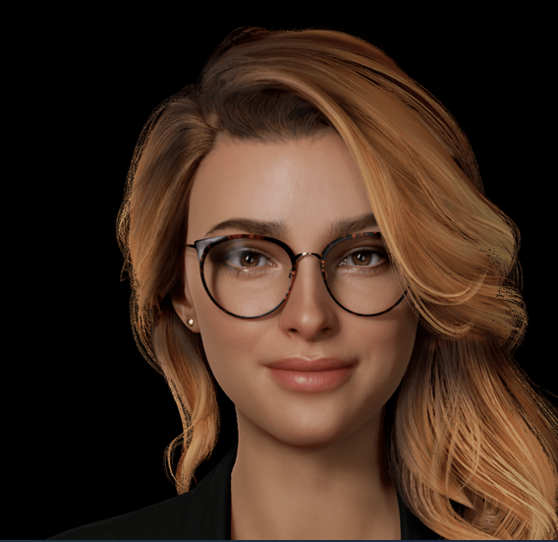

**Figure 5.1 Digital Human**

The definition of the digital humanities is being continually formulated by scholars and practitioners. Since the field is constantly growing and changing, specific definitions can quickly become outdated or unnecessarily limit future potential. The second volume of *Debates in the Digital Humanities* (2016) acknowledges the difficulty in defining the field: "Along with the digital archives, quantitative analyses, and tool-building projects that once characterized the field, DH now encompasses a wide range of methods and practices: visualizations of large image sets, 3D modeling of historical artifacts, 'born digital' dissertations, [hashtag activism](https://en.wikipedia.org/wiki/Hashtag_activism) and the analysis thereof, [alternate reality games](https://en.wikipedia.org/wiki/Alternate_reality_game), mobile makerspaces, and more. In what has been called 'big tent' DH, it can at times be difficult to determine with any specificity what, precisely, digital humanities work entails."

Historically, the digital humanities developed out of humanities computing and has become associated with other fields, such as humanistic computing, social computing, and media studies. In concrete terms, the digital humanities embraces a variety of topics, from curating online collections of primary sources (primarily textual) to the [data mining](https://en.wikipedia.org/wiki/Data_mining) of large cultural data sets to [topic modeling](https://en.wikipedia.org/wiki/Topic_modeling). Digital humanities incorporates both digitized (remediated) and [born-digital](https://en.wikipedia.org/wiki/Born-digital) materials and combines the methodologies from traditional humanities disciplines (such as [rhetoric](https://en.wikipedia.org/wiki/Rhetoric), [history](https://en.wikipedia.org/wiki/History), [philosophy](https://en.wikipedia.org/wiki/Philosophy), [linguistics](https://en.wikipedia.org/wiki/Linguistics), [literature](https://en.wikipedia.org/wiki/Literature), [art](https://en.wikipedia.org/wiki/Art), [archaeology](https://en.wikipedia.org/wiki/Archaeology), [music](https://en.wikipedia.org/wiki/Music), and [cultural studies](https://en.wikipedia.org/wiki/Cultural_studies)) and social sciences,[[6]](https://en.wikipedia.org/wiki/Digital_humanities#cite_note-digital-humanities-network-6) with tools provided by [computing](https://en.wikipedia.org/wiki/Computing) (such as [hypertext](https://en.wikipedia.org/wiki/Hypertext), [hypermedia](https://en.wikipedia.org/wiki/Hypermedia), [data visualisation](https://en.wikipedia.org/wiki/Data_visualisation), [information retrieval](https://en.wikipedia.org/wiki/Information_retrieval), data mining, [statistics](https://en.wikipedia.org/wiki/Statistics), [text mining](https://en.wikipedia.org/wiki/Text_mining), [digital mapping](https://en.wikipedia.org/wiki/Digital_mapping)), and [digital publishing](https://en.wikipedia.org/wiki/Electronic_publication). Related subfields of digital humanities have emerged like [software studies](https://en.wikipedia.org/wiki/Software_studies), platform studies, and [critical code studies](https://en.wikipedia.org/wiki/Critical_code_studies). Fields that parallel the digital humanities include [new media studies](https://en.wikipedia.org/wiki/New_media_studies) and [information science](https://en.wikipedia.org/wiki/Information_science) as well as [media theory of composition](https://en.wikipedia.org/wiki/Media_theory_of_composition), [game studies](https://en.wikipedia.org/wiki/Game_studies), particularly in areas related to digital humanities project design and production, and [cultural analytics](https://en.wikipedia.org/wiki/Cultural_analytics).

**6. CONCLUSION**

The proposed system would be a stepping stone in having in place an intelligent query handling program which could in next phases not just respond but self-learn to improve itself thereby increasing not just the quality of customer service but also reducing human load, increase in productivity and of course increasing number of satisfied customers.

**REFERENCES**

[1]J. Chai and J.Lin, “The role of natural language conversational interface in online sales: a case study,”International Journal of Speech Technology., vol. 4, pp. 285295, Nov. 2001

[2]https://www.researchgate.net/publication/338659152_Chatbots_and_Virtual_Assistant_in_Indian_Banks

[3] J. Jia, “The Study of the Application of a keywords-based Chatbot System on the Teaching of Foreign Languages.”

[4] Weizenbaum, J. 1966. ELIZA- A Computer Program for the Study of Natural Language Communication between Man and Machine, CACM 9(7), 36-43

[5]http://ieeexplore.ieee.org/xpl/articleDetails.jsp?tp=&arnumber=6225826&ranges%3D2011_2014_p_Publication_Year%26queryText%3De+banking

[6] https://www.irjet.net

[7] https://www.ibm.com › cloud › watson-assistant

[8] https://digitalhumans.com/

[9] https://www.blahbox.net

[10]https://www.nltk.org.in